RINGS-A000-EUR-Italy-Rome- Legio X Fretensis

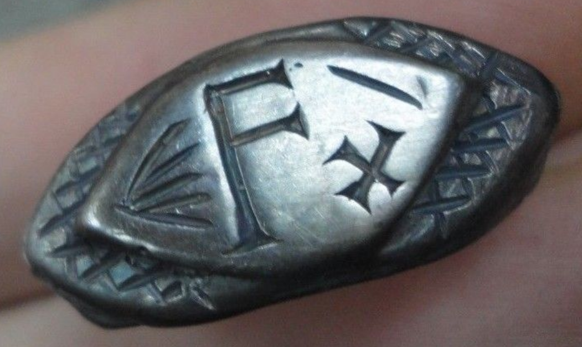

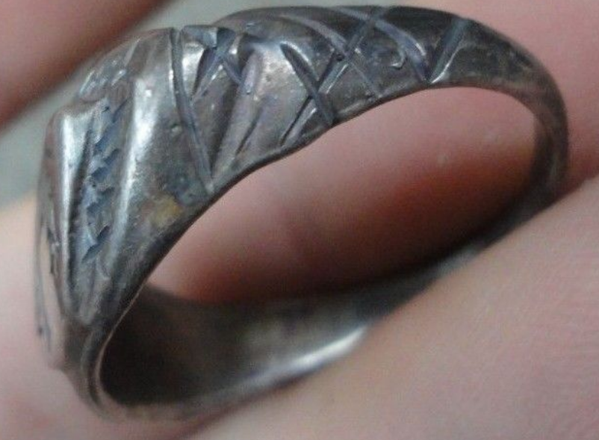 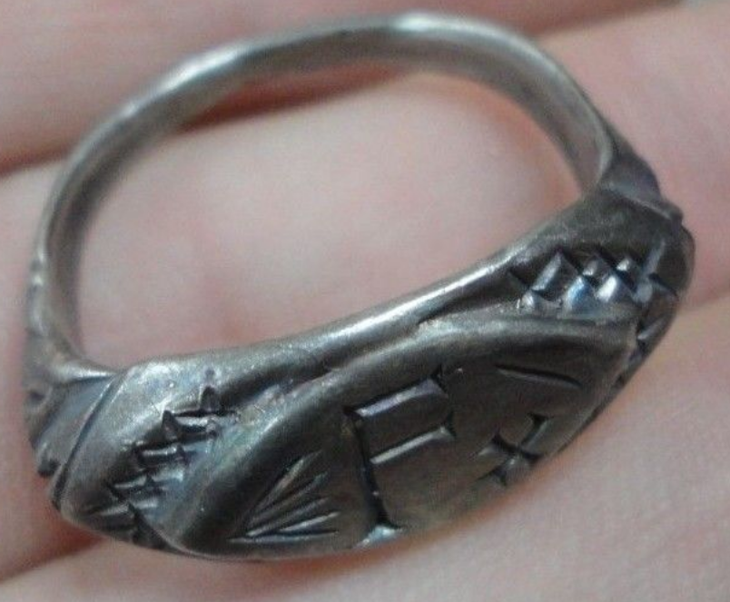 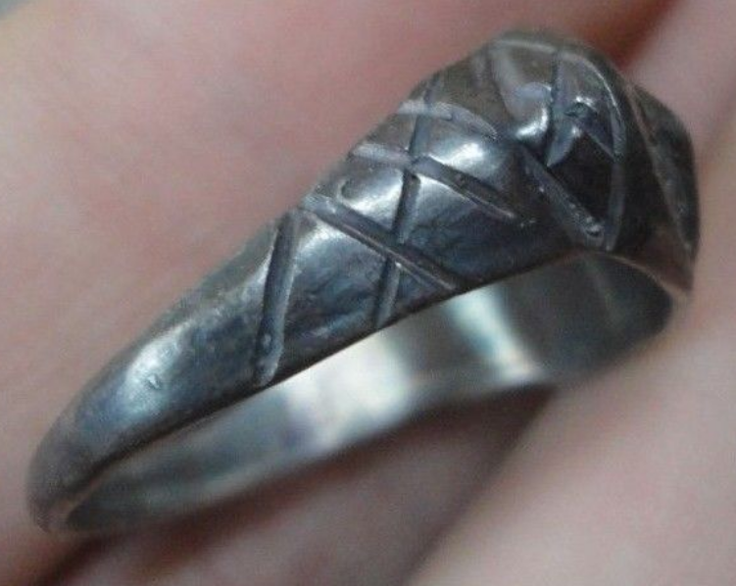 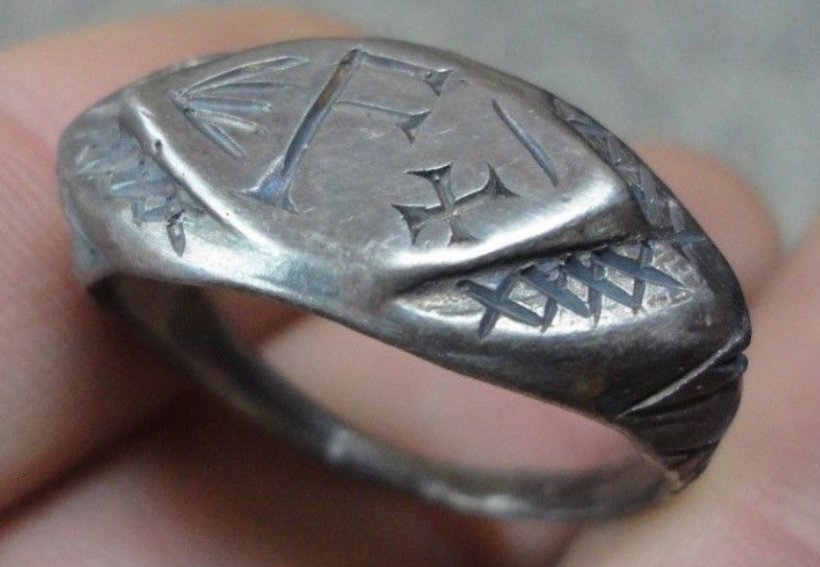

Legio X Fretensis

**Legio X Fretensis ("Tenth legion of the Strait") was a legion of the Imperial Roman army. It was founded by the young Gaius Octavius(later to become Augustus Caesar) in 41/40 BC to fight during the period of civil war that started the dissolution of the Roman Republic. X Fretensis is then recorded to have existed at least until the 410s. X Fretensis probably a reference to the Battles of Naulochus and/or Actium.**

INSCRIBED - " F - X "

EXTREMELY RARE **Roman SENATORIAL LEGIONARY SILVER ring.**

SOLID SILVER - Wearable <> 8.57 grams <>

**<> 21.50mm. = 0.86" Inner diameter <>**